**For more information, contact:**

Dan Danford, 262-636-7359

[dan.danford@caseih.com](mailto:dan.danford@caseih.com)

Julie Caan, 920-912-3445

jcaan@bader-rutter.com

**Rugged New Case IH Tiger-Mate® 255 Field Cultivator Creates High-efficiency Seedbed**

*Next-generation field cultivator matches Case IH Early Riser® planters for optimal agronomic performance*

RACINE, Wis. (Aug. 30 2016)

The new Tiger-Mate 255 field cultivator from Case IH helps producers meet productivity goals by creating an ideal seedbed in the spring. With each pass, the Tiger-Mate 255 delivers a smooth surface and flat subsurface floor. Paired with the Case IH Early Riser planter, it helps producers achieve maximum yield potential by combining a high-efficiency seedbed with the ultimate in seed placement accuracy.

“With so much emphasis on planting speed and efficiency, producers need a superior field cultivator to realize their planters’ full potential,” said Chris Lursen, Case IH tillage marketing manager.

Case IH set the standard for seedbed preparation. The next-generation Tiger-Mate 255 adds to this legacy, incorporating a redesigned shank assembly, tool-free leveling and adjustments, and a more rugged frame for increased ground speed. Now capable of speeds up to 10 miles per hour, the Tiger-Mate 255 helps producers be more productive with no loss in seedbed quality.

“Built using principles of Case IH Agronomic Design, the Tiger-Mate 255 effectively manages residue, breaks up soil clods and puts the finishing touches on the seedbed for optimal seed-to-soil contact, robust root development and even seedling emergence,” Lursen said.

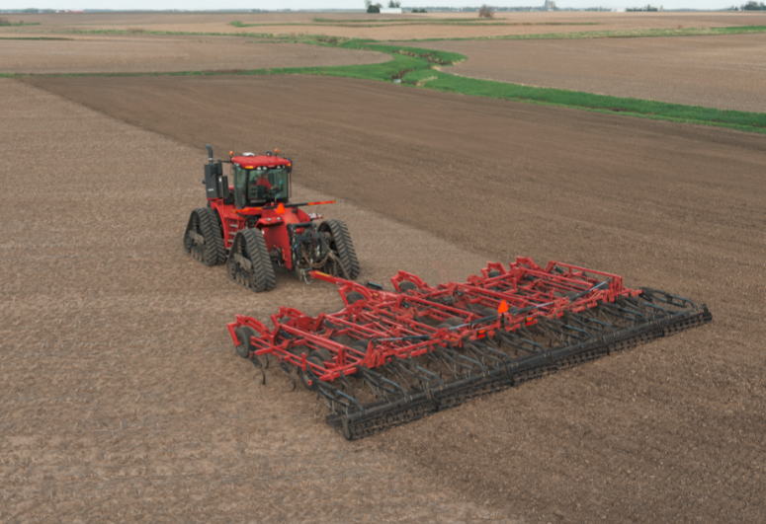

**Caption:** Enhanced features of the new Case IH Tiger-Mate® 255 field cultivator promote maximum yield potential by creating a high-efficiency seedbed.

Click [[HERE](http://www.caseih.com/northamerica/en-us/service/newsroom/multimedia)] to download a hi-res file.

**Enhanced field cultivator features**

Features and capabilities of the Tiger-Mate 255 field cultivator include:

* **Firm, yet flexible shank assembly.** The rugged new shank assembly meets the challenges of higher field speeds with 20 percent more holding power than previous models. It balances force and flexibility to keep Earth Metal® sweeps parallel to the ground for a consistently smooth surface and flat subsurface floor, regardless of field conditions and speed. From stronger compression springs to larger pivot bolts and hardened pivot-point bushings, the 11/16-inch thick shank is built to withstand the rigors of high speeds and fast-changing field conditions.
* **Split-the-middle sweep pattern.** The proven sweep pattern from the Tiger-Mate, combined with 6.5-inch shank spacing, provides 100 percent sweep coverage. This ensures maximum soil mixing and improved residue flow, even at higher speeds.
* **High-concavity shank.** The shanks break down tough clods and provide more consistent residue movement and optimal mixing.
* **Single-point depth control.** New single-point hydraulic control makes it quick and easy to fine-tune depth to accommodate varying field conditions.
* **Floating hitch.** This optional feature allows the Tiger-Mate 255 to run independently of the tractor. The implement accurately follows the ground contour for improved depth consistency on uneven terrain.
* **Stubble-resistant tires.** The industry-exclusive, long-lasting radial tires have a greater footprint to reduce compaction and improve flotation and durability.
* 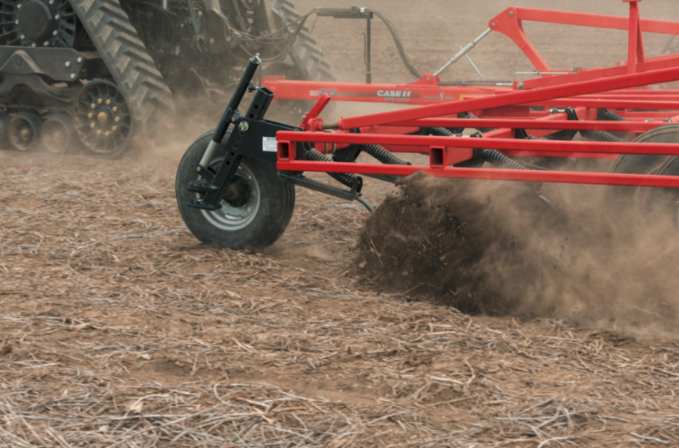**Multiple harrow options.** Choose the option to achieve your desired soil finish — including the new 3-bar, spike-tooth Advanced Conditioning System (ACS) harrow with formed TigerPaw™ Crumbler® rolling reel.

Caption: The redesigned shank assembly on the new Case IH Tiger-Mate® 255 field cultivator balances strength and flexibility to create a level seedbed at speeds up to 10 miles per hour.

Click [[HERE](http://www.caseih.com/northamerica/en-us/service/newsroom/multimedia)] to download a hi-res file.

**Tough, durable design**

The welded bridge frame of the Tiger-Mate 255 is built with strength to stand up to increased field speeds. Yet it can flex through tough, rocky ground, which helps lengthen equipment life.

“Available in single-fold sizes ranging from 22 ft. 2 in. to 35 ft. 2 in. and double-fold configurations from 37 ft. 5 in. to 60 ft. 1 in., the Tiger-Mate 255 features the same durability and productivity that Tiger-Mate field cultivators are known for,” Lursen said. “Heavy-duty components throughout this new implement help ensure reliable and low-maintenance operation for seasons to come.”

For more information, visit your Case IH dealer or [caseih.com.](http://www.caseih.com/northamerica/en-us)

Case IH is a global leader in agricultural equipment, committed to collaborating with its customers to develop the most powerful, productive, reliable equipment — designed to meet today’s agricultural challenges. With headquarters in the United States, Case IH has a network of dealers and distributors that operates in over 160 countries. Case IH provides agricultural equipment systems, flexible financial service offerings and parts and service support for professional farmers and commercial operators through a dedicated network of professional dealers and distributors. Productivity-enhancing products include tractors; combines and harvesters; hay and forage equipment; tillage tools; planting and seeding systems; sprayers and applicators; site-specific farming tools; and utility vehicles. Case IH is a brand of CNH Industrial N.V. (NYSE: CNHI / MI: CNHI).

###